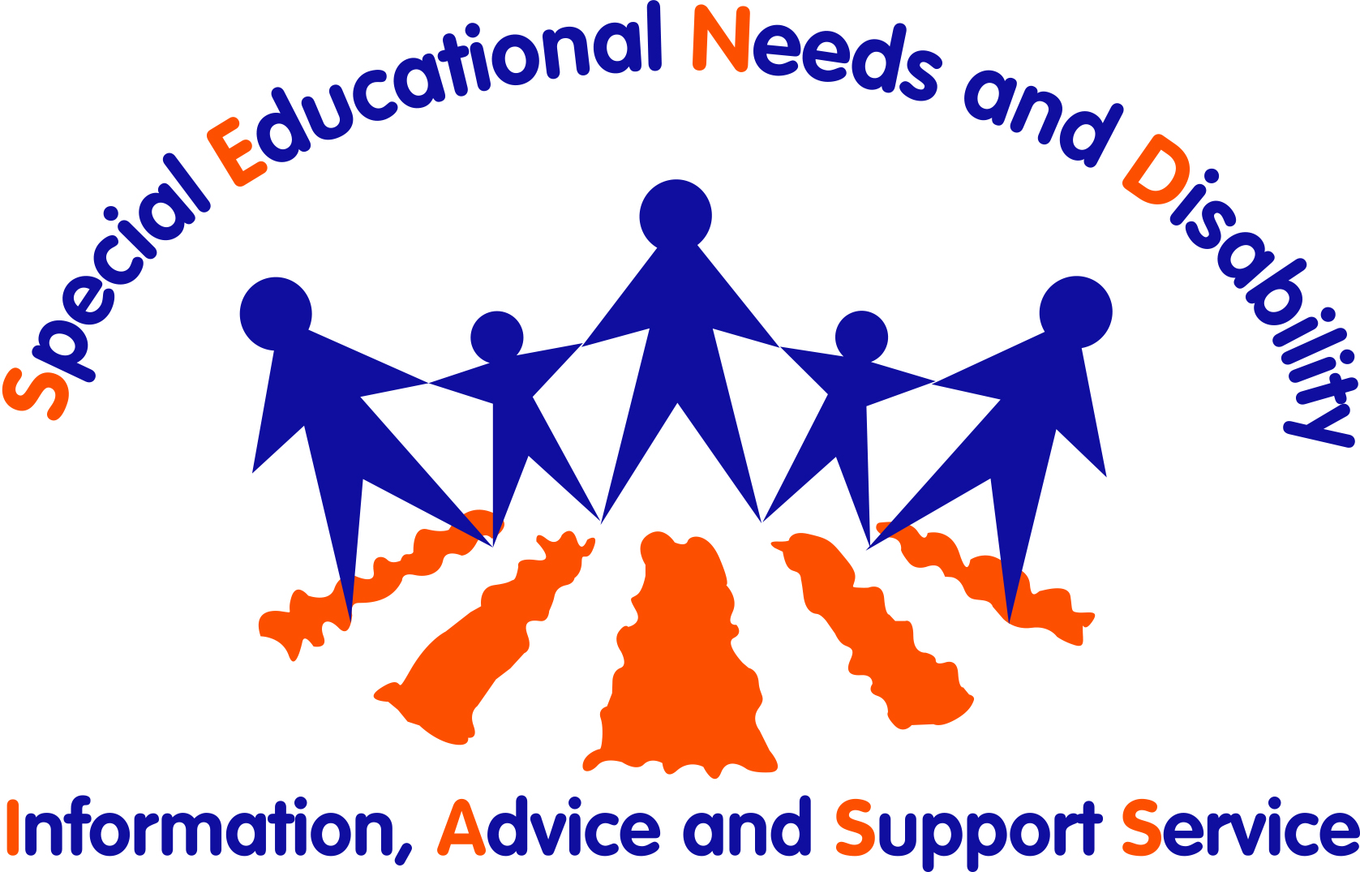
Finding out what support you need

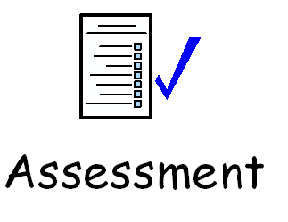
Sometimes we might need extra help in school, college or training. To find out if you need extra support, you might have an
Education, Health and Care Needs Assessment.

This is a careful look at what you might need help with. Lots of people think about what you might need and then write reports.

Sometimes it is called an EHC Needs Assessment.
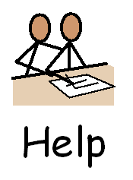

You and the people who support you will think about what you can do on your own and what you might need extra help with. They will try to work out if you need any extra support.

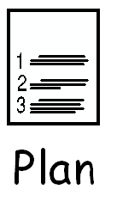
At the end, they will decide if you need a plan to get you extra help in your school, college or training. This would be called an Education, Health and Care plan.

If you are over 18 you might need a plan to make sure you can finish your education or training.

Who should have the assessment?

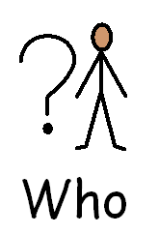
You may be able have to an EHC Needs Assessment if:

- you are 0 - 25 years old, and,

- you have special educational needs. This means you need extra help to learn things, and

- your school or college may not be able to give you all of the support you need.

What is in the assessment?

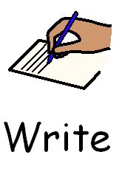
You and your parents or carers will be asked if you want to write down or to say what you think about your needs and support.

Lots of other people will also help write reports, including:

- Your school or college
- People that support you
- An educational psychologist. This is someone who knows lots about how people learn.
- If you see them, doctors and therapists
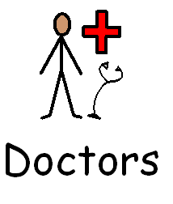
- If you use social services or need to, social workers
- If you have problems with hearing or sight, teachers who know lots about those things
- Any other people you want to write reports to explain your needs

The law says that the local authority must send everyone what you have said you need, or any reports you want them to look at.

How do I get an assessment?
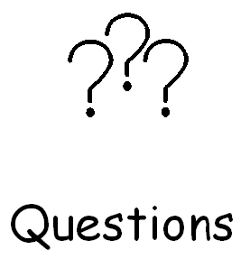
You can ask for an assessment if you are aged between 0 - 25 years old and you think you might need one.

Other people that can ask for you are:

- Your parents or carers
- Your school
- People who work with you, like doctors or teachers
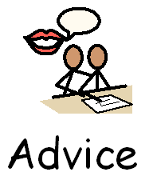
If you want any help getting an EHC Needs Assessment then you can ask the SEND Information, Advice and Support Service. If you do not agree with anything then they can make sure your views are heard.
Ask one of our members of staff for support.

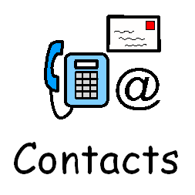
Please contact us on Tel: 024 7669 4307 or
Email: iass@coventry.gov.uk or
Follow us on Facebook
Follow us on X (Twitter)

