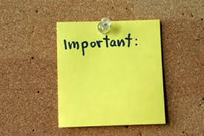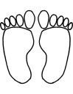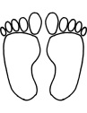

* I dream of



**Things I want people to know about me**

**MY**

**DREAMS**

**Sometimes I worry about**

**People who know me say…**

SCHOOL NAME 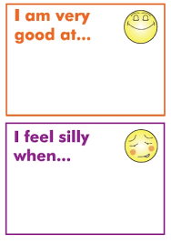N

y

**These people helped me write this:**  **They helped me by:**

**Completed:**

**In the community and at home….**

**At school …**

[](http://www.google.co.uk/url?sa=i&rct=j&q=&esrc=s&frm=1&source=images&cd=&cad=rja&uact=8&ved=0ahUKEwiomKPZwq_LAhVDEJoKHZLRCCIQjRwIBw&url=http://mrahayes.com/project/today-is-a-good-day&psig=AFQjCNGMRxYsn9oqucWltFevFC_O4GAMgA&ust=1457472423809853)

[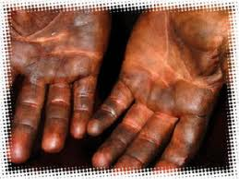](http://www.google.co.uk/url?sa=i&rct=j&q=&esrc=s&frm=1&source=images&cd=&cad=rja&uact=8&ved=0ahUKEwiu7JmOs67LAhXDWRQKHZh2DLwQjRwIBw&url=http://liftright.net/Forklift-Safety-Basics.htm&psig=AFQjCNFSxnJPykXRKNlak6J76CsOB4ZIiA&ust=1457433959364479)