

SEND Information Advice and Support Service

Annual Report to Steering Group

5th July 2019

Contents:

Overview
Commissioning, Governance and Management Arrangements
Strategic Functions
Operational Functions
Professional Development and Training for staff

SEND Information Advice and Support Service
Report to Steering Group – 5th July 2019

Overview

From 1st September 2014, Local Authorities have a statutory duty to provide SEND Information Advice and Support Services as outlined in the Special Educational Needs and Disability Code of Practice (0-25 years) 2015. In September 2018, a new set of minimum standards were introduced as part of the Information Advice and Support Programme (IASP) which services are expected to meet, these standards are supported by the DfE and Department of Health and Social Care. They are based around four key areas:

- Commissioning, Governance and management arrangements
- Strategic functions
- Operational Functions
- Professional development and training for staff

These minimum standards outline clear expectations of SEND Information Advice and Support Services. They act to support both LA’s and services themselves to ensure the quality of the service provided, and its impact for service users. They are also the basis for 2-year operational plans for 2019-2021 and linked funding in 2019/20.

The minimum standards can be read online, through the IASSN website.

Paragraph 2.19 of the Code of Practice outlines the key roles of the IASS:

To meet local needs, local authorities should consider providing the following forms of support through their information, advice and support service(s):
- Signposting children, young people and parents to alternative and additional sources of advice, information and support that may be available locally or nationally
- Individual casework and representation for those who need it, which should include:
o support in attending meetings, contributing to assessments and reviews and participating in decisions about outcomes for the child or young person
o directing children, young people, parents and those who support and work with them to additional support services where needed, including services provided by the voluntary sector. These services should include support relating to preparing for adulthood, including housing support, careers advice and employment support
- Help when things go wrong, which should include:
• supporting children, young people and parents in arranging or attending early disagreement resolution meetings
• supporting children, young people and parents in managing mediation, appeals to the First-tier Tribunal (Special Educational Needs and Disability), exclusions and complaints on matters related to SEN and disability
• making children, young people and parents aware of the local authority’s services for resolving disagreements and for mediation, and on the routes of appeal and complaint on matters related to SEN and disability (see Chapter 11, Resolving disagreements)
- Provision of advice through individual casework and through work with parent carer support groups, local SEN youth forums or disability groups, or training events

In addition to the above, the Service also assists parents where their child has been excluded or is at risk of exclusion from school.

In its previous guise (Coventry Parent Partnership Service) the service was both well-established and well-regarded, both locally for service users and professionals, and further afield working with the national network of PPS’s. As with the PPS, the SENDIASS receives its funding from the Local Authority (LA) but operates at "arms length" from it, to ensure parents have confidence in the impartiality of the advice, support and information provided by the Service.
The following report seeks to inform members of the Steering Group on the work and developments of the Service since the last meeting of the group which was held in June of the 2017/18 financial year.

Commissioning, Governance and Management

Staffing:

Following on from a slightly strained last couple of years, this year has seen a more settled staffing pattern. We were able to continue to fund additional hours for 3 current staff, whilst also having a new SEND IASS Officer position created to fill the vacated post at the end of 17/18. Due to the uncertainty of funding moving forward, and an elongated recruitment process, we finally welcomed Elley Aiyedofe into the team in January 2019.
The post is originally a fixed term position, aimed to fulfil the duties on the service of the IAS Programme, but with the hope that this can be extended (ensuring staffing levels are maintained in line with previous levels against a backdrop of increased referrals). The post was also changed from its previous incarnation of all year round to term time only; given the general drop off in referrals traditionally in holiday periods, it was felt that having one staff member for these times meets service need. It also enables staff to be more flexible in when they work, which works well for all staff.

Finance:

2018/19 – The baseline core budget based on previous reporting through these reports was £134,107, however this did not include £21,360 which is allocated to organisational overheads contributing to building and support costs. Therefore the total budget totalled £155,467. This was supplemented by an additional £9,748 carried forward from the Independent Support contract, supporting the continuation of the Children & Young People’s post. The IS contract was also extended for the first two months of the financial year (Apr/May 18) which provided an additional £3,472.
The impact of the loss of the Independent Supporters programme, which had supplemented the service’s finances since September 2014, was mitigated by a new pot of money through the new Information, Advice and Support Programme (IASP), which allocated an additional £32,000. This was allocated solely towards producing a 2yr operational plan towards meeting the new “Minimum standards” and applying for associated linked funding.
All told, this meant that the overall Budget for the year was £200,687 (£179,327 on previous figures). Our spend totalled £154,886. We were able to carry forward £11,029 of the grant funding, which meant that in total we were underspent by £34,772 on core budget.

2019/20: The baseline budget was set at £166,096. This increase of just over £10.5k is due to a general increase in staffing costs (across the City council, and changes to pension arrangements).
This was supplemented by the £11,029 carried forward from the previous years’ IASP funding. We were also successful in bidding for additional funding through the IASP programme for 2019/20. This amounted to £35,100 from 3 funding pots. Altogether this amounts to a total budget of £212,225. It is expected that there will be a significant amount of underspend, particularly of the additional funding this year. However, as the development plan is over 2 years, but currently only funded for one, we are working to try and ensure that we can keep current staffing levels to meet the outcomes.

Strategic Functions

Over the course of the 2018/19 year, the service has contributed in a number of ways to overall strategic functions in the context of local, regional and national developments.

Local

  - We regularly attend the local SEND Board, especially with a view to supporting the involvement of young people and their parent/carers. This has also led to the development plan in ensuring that we have children and young people contributing to the issues affecting them in relation to SEND.

  - SEND IASS was represented in a local working group looking at the educational offer to youngsters who are out of school, particularly in regard to mental health/anxiety and associated SEND. The group also had service user involvement but ended prior to April.

  - Continued to support the Parent Carer forum in producing an “Ask the Experts” event, in which parents/carers are able to ask questions of senior officials across education, health and social care in order to shape future provision and practice.

  - We continue to produce an e-bulletin which is distributed through the LA, which supports the “Local Offer” workstream. This is on a 6 weekly cycle but is still very much an “in-house” production – we continue to get little or no information from sources across education, health and care (or indeed from service users).

  - Worked with Public Health to monitor the parenting strategy across Coventry.

  - Contributed to a local group looking at the “My Support Plan” document which has been developed for supporting Coventry pupils at SEN Support stage.

  - Contributed to a peer-led local inspection of SEND services within the Local Authority. This also complimented preparations for an expected Ofsted/CQC inspection in the coming months.

  - Supported the local authority in redesign of the Local Offer, including working with young people; contributing to working groups focussed on “Preparing for Adulthood” across Education Health and Social Care; organising drop ins for parents to meet with LA representatives.

  - Continue to attend the local “Further Education” group with colleges to discuss issues for post-16 learners.

  - Signposting other agencies, particularly health and social care, to publications/events aimed at staff from those areas around the reforms/EHC plans.

Regional

SENDIASS Manager has continued to attend the regional “Preparing for Adulthood” working groups, with a view to developing resources in this area. However, some of the meetings had a focus on very specific areas which would not have been particularly relevant for the service.

Coventry IASS is a member of the regional West Midlands group for SEND IAS services, and service manager is currently the chair of this group. Coventry also has responsibility for the finance of this group as it works collaboratively in providing training opportunities for staff. It meets on quarterly basis through the year and includes involvement from the national network (IASSN).

National

- National developments have focussed over the last year in looking at the future direction of IASS services and how they are delivered. This Information, Advice and Support Programme developed by the Council for Disabled Children, has been in place since July 2018, and alongside the minimum standards seeks to support a comprehensive offer by IAS services.

As part of the evaluation of the first year of the programme, the IASS had to produce a case study to examine the effects and impact of the year, which was then published as an example of good practice on the IASP website.

The IASS Network, provides an online forum to support both managers and staff of services, which Coventry has an active engagement with.

Provision of Information & Advice and Supporting Individuals

Individual casework support

SEND Information Advice and Support Service operates an open referral policy. This provides confidential, impartial information, advice and support to parents/carers, children and young people of Coventry aged 0-25 years who have special educational needs and/or disabilities, are excluded or at risk of exclusion from school. This remains a large and broad area for a service previously aimed solely at supporting parents/carers, with slightly increased staffing arrangements in place

Through liaison and partnership working the team provides active support to contribute to positive outcomes for children and young people. Dependent upon the individual characteristics of a referral for support the Service also works pro-actively on behalf of families across a wide range of statutory and voluntary agencies to secure good outcomes.

Individual casework support around Special Educational Needs and Exclusion continues to be the core element of activity with Officers supporting parents at SEN support meetings, issues around exclusion, annual reviews and throughout the EHC needs assessment process. The service operates a “Duty Officer” system where parents can usually speak to an IASS Officer on the same day, although as referrals have increased, this has become slightly less likely.

For many families IASS continues to take on more of a key worker / co-ordination role, often for those who are socially disadvantaged, where parents themselves have significant needs or who are simply worn out with the constant demands of supporting the additional needs of their child.

Case work support necessitates staff being able to draw upon a range of competences and methods using a high level of interpersonal skill. At times it requires an amalgam of skills and abilities usually identified in areas such as counselling, negotiation, mediation, conflict management and advocacy.

Cases require a great deal of knowledge, patience, encouragement and understanding together with liaison across a range of statutory and voluntary agencies in an attempt to reach a resolution and effectively support the family.

Due to capacity issues and in order to maintain an element of control over the large number and complexity of cases presented to the Service the “casework criteria” which determines the level of IASS intervention is used consistently and is very well established. Contacts are generally recorded as either;
Casework – where full details of the case are discussed with a child/young person or their parent by an IASS officer;
OR
General enquiries – where generalised information is given either where an individual child/young person is not identified or to a professional working with them.

Presenting issues:

Some of the issues / pressures arising from casework support fall into the following areas (since last report):

- SEN support enquiries increasingly about schools/colleges informing parents that they are unable to provide the support required due to lack of funding. This often results in parents feeling that their only option is to make a parental request for EHCNA.
- Lack of special school places continues to be a major issue resulting in the need for IASS to assist parents with further negotiation with mainstream schools around support arrangements or lodging appeals (even though all of the professionals involved in the case are in agreement that the child/young person needs a special school place).
- A large number of queries regarding part-time arrangements/unofficial exclusions and youngsters out of school, particularly in the summer term of 2018. This has reduced with new LA guidance around part-time timetables, in September 2018.
- The long waiting times associated with a number of services, particularly where referrals have been made to specialist health services (including those with EHC needs assessments).
- Issues around securing transport against a backdrop of new arrangements, particularly those in post-19 provision (Summer/Autumn term 2018)
- A number of children missing education, mainly new to the city, where provision has not been identified.

IASS Casework Support Figures: 1st April 2018 – 31st March 2019

Yearly analysis

This period saw the introduction of the new casework management system, meaning a change in the way that some figures were recorded. Any year on year changes are explained in each section.

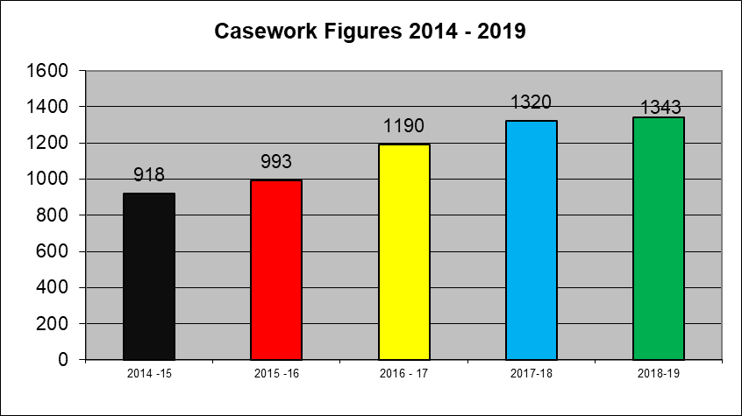

The first plateau in overall casework figures since the reforms in 2014, following large jumps in the previous two years. This has seen an increase in those classed as “casework” (23%) and a similar drop in those classed as “general”. This would indicate that more enquiries are being received from service users, rather than through other professionals, although changes to our administrative procedures may also have enabled us to ensure that more individualised cases are identified.

Ongoing cases:
April | 120 | October | 140
May | 136 | November | 136
June | 143 | December | 128
July | 117 | January | 113
August | 130 | February | 123
September | 137 | March | 124
Number of contacts:
April | 129 | October | 374
May | 342 | November | 302
June | 325 | December | 220
July | 261 | January | 307
August | 95 | February | 335
September | 281 | March | 311

The depth of this individual on-going casework across a range of agencies per case is difficult to break down from current monitoring resources. Many of the cases that IASS become involved in are complex and require significant liaison between a number of agencies over a period of time to establish the issues and endeavour to seek solutions. They are monitored through termly reviews between the manager and officers.

However, we now do have the option to record the number of contacts received in any given month (as above). This gives an idea of the depth of work provided, however it is still reliant on inputting of information into the system after every contact – this is likely to be under-reported due to the nature of some of the contacts and time factors in recording. The intention is for a “deep dive” into some of these cases in 2019/20, particularly those which have had involvement over a long period.

Response time: April 2018 – March 2019

The new casework management system has generally had a positive impact on recording, but some teething problems initially in establishing an accurate way of recording response times, means it is difficult to indicate, with confidence, response times for all cases. This was mainly due to how cases, particularly those which were logged and dealt with immediately, were recorded on the system. From September 2018, 99.5% of calls had a response within the 2 day service standard (an increase of 0.3% on the previous year).
Confidence on same day responses is very low, as figures suggest this at 49%. However, given the huge drop off from 2017/18, when it was 85%, it is difficult to suggest this is a true figure.

Discussions have taken place with the system provider to look at a more robust tool for this recording, particularly as this is an area which has an outcome attached to it through the IASP funding.

Type of SEN

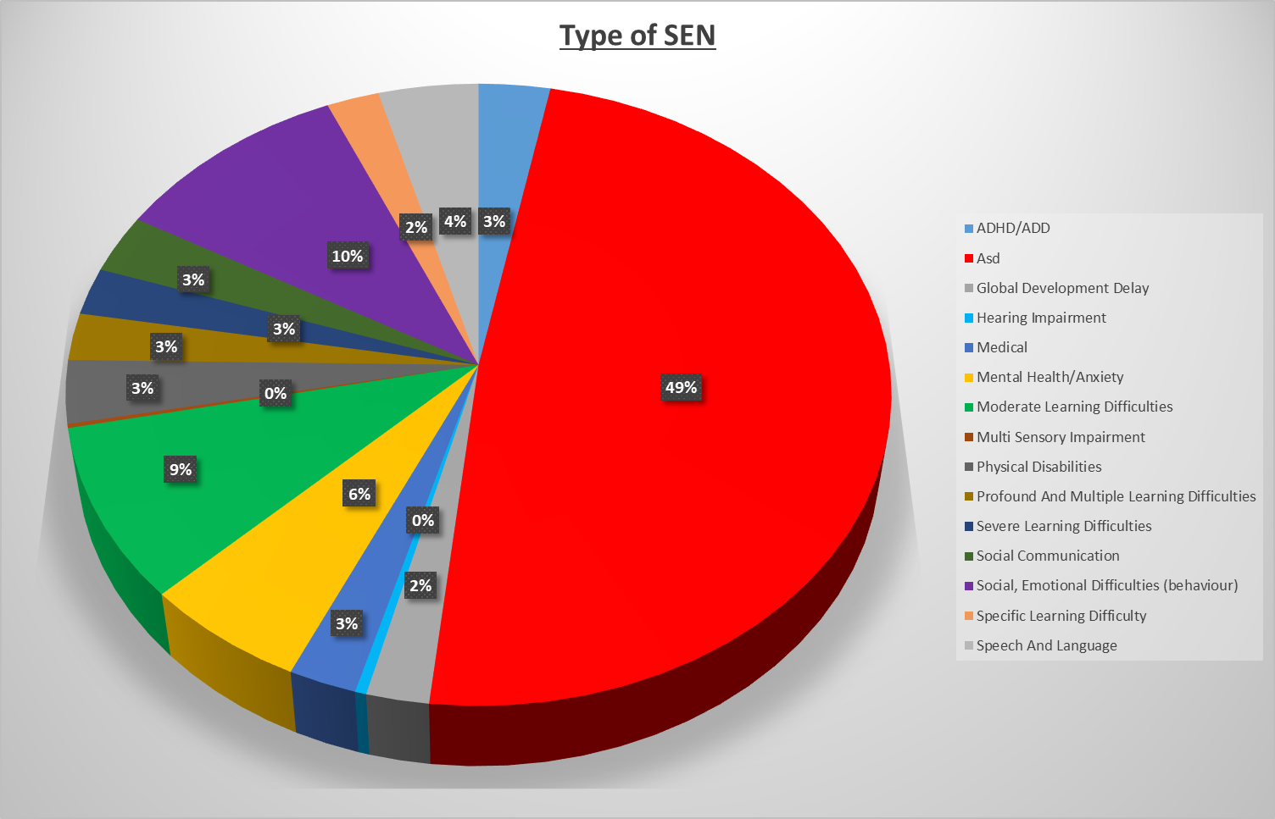

ASD continues to be by far the largest percentage of primary area of need reported by service user during a referral, showing a 7% increase from the previous year. There has been a widening of categories in the last year, to try and show more specific areas of primary need, but this still doesn’t necessarily highlight some particular areas of concern, particularly with regards to things like mental health/anxiety. Whilst this has featured in an increasing number of cases, it is often found under another area of need e.g. autism, social and emotional.

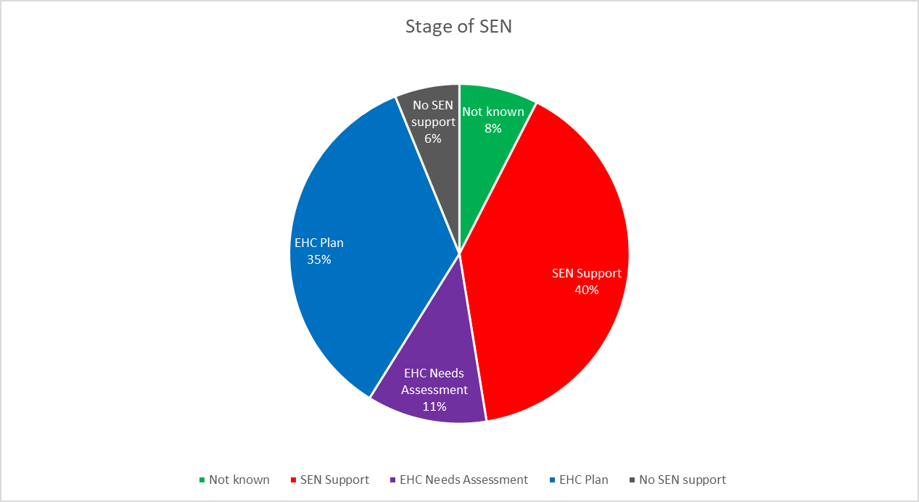

Since the implementation of the SEND reforms in 2014, we’ve seen a gradual shift towards more statutory related referrals. This years’ split was almost exactly the same as the previous year.

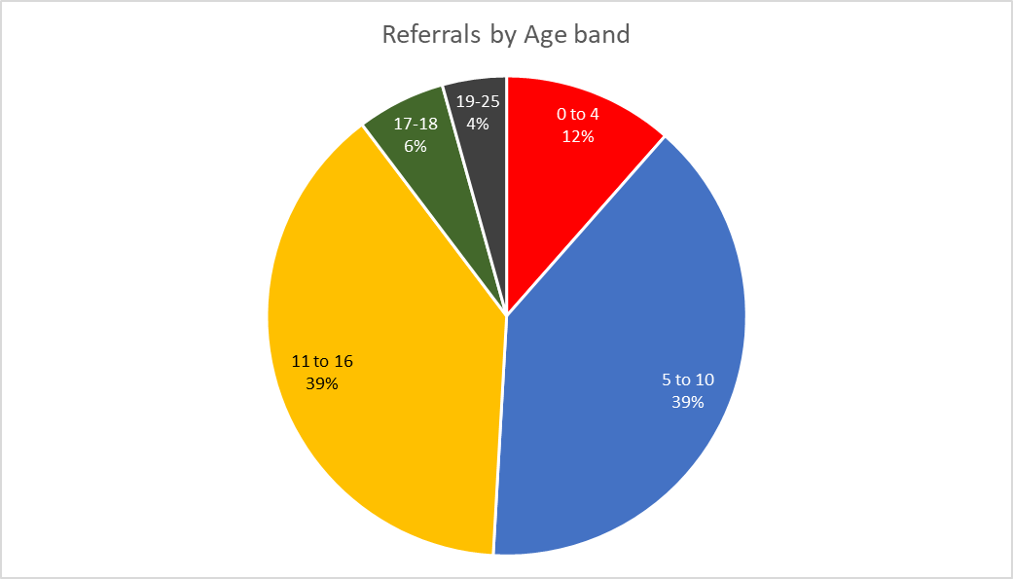

Although the figures are now broken down into age bands rather than year group, the figures are almost identical to last years’ in respect of the age of the young person. The only real increase was the numbers of young people aged between 19-25, which increased by 2%. This is not unexpected in that it reflects a general increase locally in those youngsters who have EHC plans in this age band.

Service User Feedback

Customer satisfaction continues to be very high, in both evaluating referrals (appendix 1). and also of parent sessions. Whilst we still do not capture the volume of feedback which we would like –the aim is for 50% of referrals – due to the increase in volume of referrals, a change would be needed to achieve this figure. As most feedback is currently collected through direct contact via the phone, this depends very much on people being available at times of contact. Therefore, based on this, and the trend for collection over the past couple of years, it is likely that 30% would be a more obtainable figure (based on current figures this would probably equate to something like 180 responses per year).

Most pleasing is that on the scale of 0-4, with 4 being the most positive response, 95% or more respondents scored the service at either a 3 or 4 for five of the six questions. The other question which scored lower (84% scored at 3 or 4) was around “the difference that the service had made for you” – many of the lower responses focussed on elements which the service had little or no control over or those parents whose knowledge had merely been affirmed.

Information, publicity and communication

Ebulletin/mailing list - The e-bulletin continues to be a prime source of information communicated to service users and other organisations. This was originally set up to work alongside the Local Offer, incorporating updates from across education health and care. However, it remains an almost entirely SENDIASS production, with only occasional input from other agencies. The bulletin is distributed to 2193 subscribers.

The mailing list is held through our casework management system, and includes both service users and professionals. This currently lists almost 550 parents/carers, and also covers all schools and colleges, Family Hubs, and a variety of health professionals.

Website/social media - The web page is reviewed through a 6 monthly cycle and has seen a recent monitoring to ensure that information is still all relevant. It was decided that given the changes outlined in the minimum standards, and in discussions previously had with Steering Group, that the service should ensure that the website is held outside of the main council pages, both to ensure that the impartiality of the service is reinforced and there is no confusion about the origins of information. This is currently in progress and is one of the service outcomes monitored through the development plan for 2019/20.

Our Facebook page continues to grow in its number of followers and has increased its reach by 39% in the period (605 current followers). Its primarily used to highlight SEND IASS events, or local information, but has become an increasing source of questions by service users. Following the launch of the coffee morning, we were also asked if there could be a closed group which would enable coffee morning attendees to discuss issues with each other. This has 13 members and is monitored by the service (including requests to join).

We have 306 Twitter followers, which has increased by only 5% in the same period. It is felt that this platform is more useful to the service to find out information from other agencies, than it is for communicating to service users. Many of the followers are schools, and some will share SEND IASS tweets, which obviously means a potential wider audience (although this has not been reflected in anyone then subsequently following the service directly.

Information leaflets – We continue to provide a wide range of information leaflets, some of which have had some changes. The service is also considering more generic information sheets which can be sent to service users as a source of useful links across the most popular topics of support – namely ASD, school transport, appealing decisions. These will be looked at through the summer term of 2019 with a view to them being ready to disseminate in September (and be included as useful guides on the new website.

Events – We have done some collaborative events alongside other agencies this year and created the foundations for more community based drop-ins into 2019/20. This was partly due to feedback to the drop-in session held at Limbrick Wood Centre in October 18, which suggested that some service users found it more difficult to get to the centre. There was also feedback throughout the year from some working parents who would like to have attended sessions, but couldn’t due to their working patterns. Consequently, we have ensured that there will be opportunities to do more twilight/evening based sessions in summer 2019 to see how well they are attended.

We have also linked closely with the One Voice group and the LA to support joint events, including the “Ask the Experts” event in November, and one around home to school transport arrangements in June. These were both informative events, but also a way to ensure service users voice in strategic development.

The service Coffee Morning was launched in June 2018, and offers service users the opportunity to meet with other parents and discuss issues. There is no fixed agenda, which is generally driven by the group, but ensuring that everyone has the opportunity to talk! Attendance has varied over the course of the year, with a high of 14 and a low of 2! It is held centrally, and we are keen to continue to offer this. We are also considering ways of offering this as a twilight/evening activity.

Parent Training/information Sessions – We’ve continued to provide information sessions for parents on a monthly basis, which are well attended and cover a range of special interest areas. A full report can be found in Appendix 2.

However, whilst we have been fortunate in being able to offer a wide range of sessions, this has proved more difficult over the last couple of years, especially when operating on a strict budget. Many of our sessions are provided with organisations who give their time free of charge, and with diminishing resources, or changes to their funding streams, this is providing a barrier to some of the offer. There is a good chance that Contact – who have provided sessions over many years – may not be able to offer this in 2019 and beyond which potentially leaves a big hole. While we are likely to have budget to provide some similar sessions next year, this may not be the case moving beyond that.

Networking and Collaboration

Service staff regularly visit a variety of groups, services and events to promote the services provided by SEND IASS.

Some examples include:
- Attendance at a number of school/college open evenings / coffee mornings to promote IASS, provide information and deal with individual parent enquiries related to SEN.
- Attendance at Woodfield School Year 6 Transition Evening and Baginton Fields/Sherbourne Fields parents evenings.
- Attendance at information fair at The Carers Centre (Coventry Trust)
- Termly SENCo meetings.

We have also met with the LA’s Ethnic Minority Achievement Service to plug the perceived gap in access to SEND information advice and support, particularly by families who are new to the city. Due to changes within the EMAS service, it was felt that a refresh of roles would be useful in order for font line staff to be aware of SEND IASS and what we can offer, particularly in partnership. This was highlighted through a number of cases where families were missing out on important information in accessing SEND provision (and education in general). There are plans to provide some basic training for EMAS staff around SEND into 2019/20.

Parent/young people’s Participation

Families of Woodfield Group - The group is now well established and continues to be supported by IASS with the school having identified two members of staff (Primary & Secondary) to support the group and liaise with senior managers at the school.
The group meets once a month and continues to have a steady flow of new parents that have expressed how much they value the group. This has included parents being encouraged by staff members to have a voice in making suggestions about school life, resulting in positive and trusting relationships. Parents have also found mutual support extending outside the group, including encouraging friendships with their children.
Children and Young people

This year we have again made attempts to expand the opportunities to involve children and young people in engaging with the service, and contributing to strategic arrangements. The Children & Young Person’s officer has worked alongside a range of partners to engage with this group of service users, both in groups and on an individual basis. This has helped to engage 86 young people over the course of the year (where parents were not also engaged).

Some of this work has focussed on specific projects, including; consulting on the new Local Offer website working alongside a staff member from the Local Authority; working with a couple of youngsters from Coventry College to help design a transitions guide for Preparing for Adulthood and building content with groups of youngsters in secondary mainstream/special school; preparing young people at Bishop Ullathorne school to produce a child-led dyslexia training programme for staff. This is a very exciting project and one which we hope will lead to a successful example of children and young people taking the lead in influencing the support they receive in education settings.

These interactions though also offer the opportunity to introduce SEND IASS to young people, and to discuss any other issues which they have questions about; this has proved more effective in trying to engage this age group than through more traditional leafleting/posters.

The C&YP officer has continued to attend the LA’s strategic board, which is recognition of the work she has done. This has included laying the foundations for a “shadow” SEND board, where children and young people (initially from special schools) will meet together to reflect on strategic priorities and create some of their own. We also have plans in place to extend this into a more informal club for those attending mainstream schools in 2019/20.

She is also heavily involved in the network of IAS services, spreading the good practice that she has developed to other services, both nationally and regionally.

Professional Development and Training

Staff involved in case work are all trained through IPSEA’s legal training – 100% of long-term staff through to Level 3 (the highest level), and the new officer working towards completing the level one. This has been supplemented by training events throughout the year provided by the IASSN network and CDC, around different subject areas.

Staff have also been trained in a range of online training programmes through the Local Authority’s online training portal, including Data Protection and GDPR, and had an assessment of their IT skills (which they all passed!).

Staff have also been asked if they would like to complete a formal qualification in SEND Casework offered through NASEN. However, the benefit that the staff have recognised has been balanced by the additional time pressure of completing and what they would be able to use the qualification for in the future, particularly as their IPSEA training covers a large facet of the knowledge needed for the job.

All staff receive regular termly casework review with the manager, allowing them to discuss progress of cases assigned to them.

